***Florida International University***

***School of Computing and Information Sciences***

Software Engineering Focus

Feature Document

User Story #844

**Team Member:**

April Perry

**Product Owner(s)​**:

Gummi Traustason

**Mentor(s)​**:

Masoud Sadjadi

**USER STORY​** - **“App- Detailed History View option”**

* As a PLAYER, I would like to have the option to view more detailed specifics of past games I played, so that I can keep track of my skills.

Acceptance Criteria

* Player must be a registered user
* Player must be logged in
* Player must have saved data after each play

**Use Case #844....​ “App- Detailed History View option”**

**Use Case Diagram**

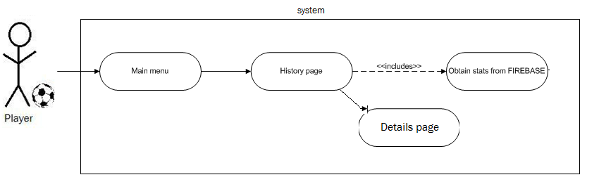

**Sequence Diagram**

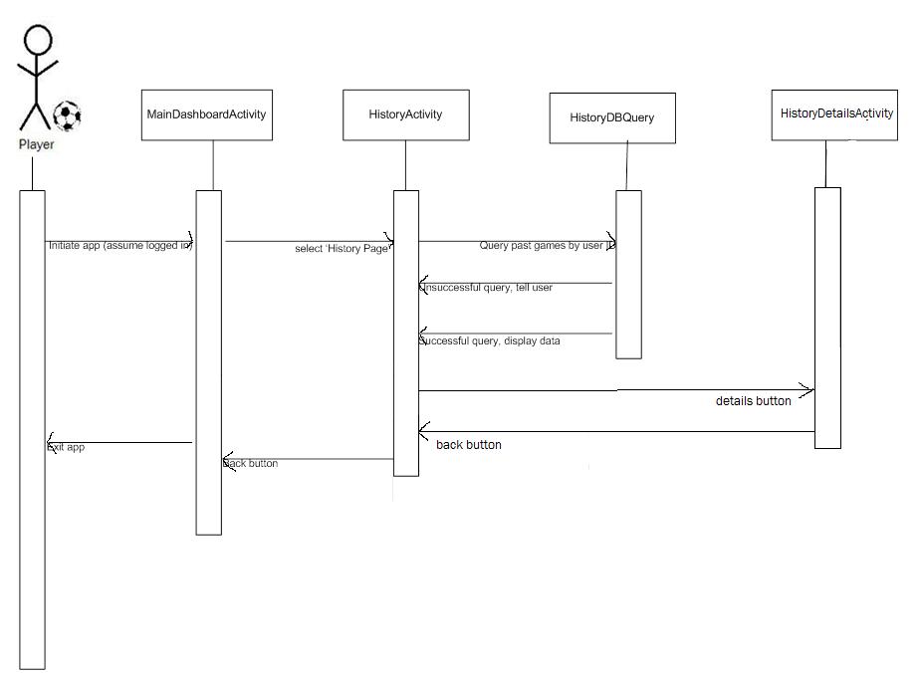

**Class Diagram**

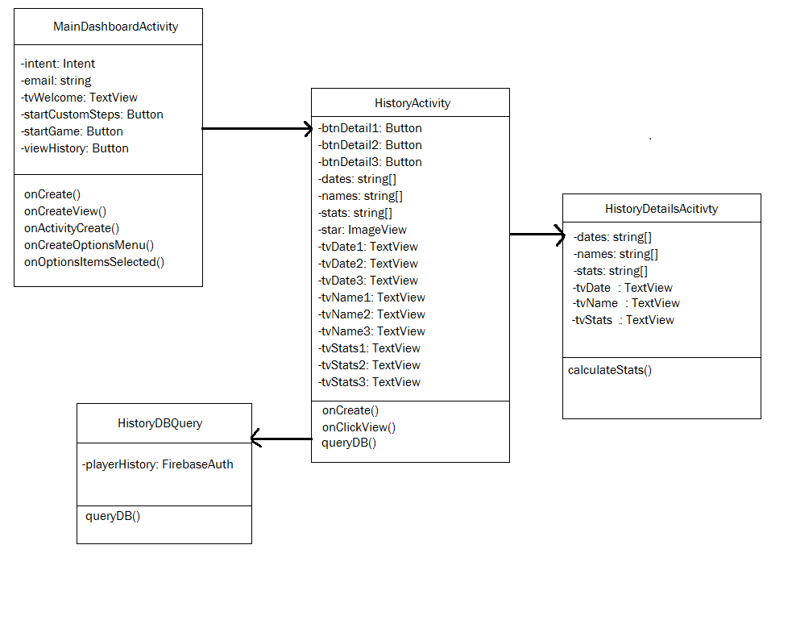

**Unit Test**

* Test Details buttons (each of them) on history page
* Test functionality and layout of history page
* Test functionality and layout of details page

**Integration Test**

- Login to app and main dashboard

- Make sure other buttons still work

- Make sure that the original layout was not altered

- Make sure new button works

- Make sure new layout flows well with rest of app

**Visual Diagram**

